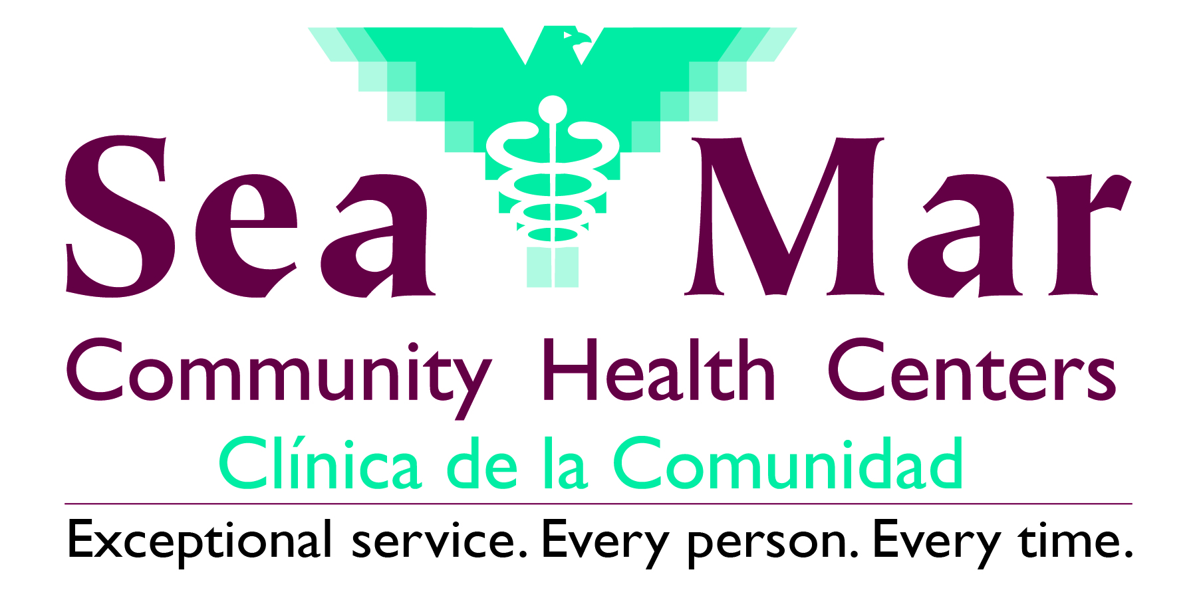

Community Demographic Form

Patient Name: | Patient ID:
Patient Preferred Name:
Pronouns: □ He/Him □ She/Her □ They/Them □ Other ___________________________________________

Gender Identity
What sex were you assigned at birth on your original birth certificate (check one)?
□ Male □ Female □ Intersex □ Decline to Answer

Do you think of yourself as (check one):
□ Man
□ Woman
□ Female-to-Male (FTM)/Transgender Male/Trans Man
□ Male-to-Female (MTF)/Transgender Female/Trans Woman
□ Gender Queer, neither exclusively male or female
□ Additional gender category/Other, please specify: _____________________________________________
□ Decline to Answer
Sexual Orientation
Do you think of yourself as (check one):
□ Straight or heterosexual □ Lesbian, gay or homosexual □ Bisexual

□ Something else, please specify: _______________________ □ Don’t know □ Decline to Answer
Migrant and Seasonal Farmworker Status
In the past two years, have you or a member of your family worked in agriculture/farming, forestry or fisheries as your/their main employment including, but not limited to: Preparing, irrigating or spraying the fields, nurseries, orchards; Planting, picking, sorting, packing or transporting fruits, vegetables, grains, nuts, plants, tobacco, hops, flowers, grass, alfalfa, hay or other agricultural products; Planting trees, working with Christmas trees, picking pine needles or Spanish moss; Working on farms that produce chicken, ducks, turkeys, cows, goats, sheep, horses, fish, seafood, etc.?
□ Yes □ No

In the past two years, have you or a member of your family established a temporary home in order to work in agriculture?
□ Yes □ No

Have you or a member of your family stopped the need to establish a temporary home to work in agriculture because of disability or old age?
□ Yes □ No

In the past two years, have you or a member of your family worked in agriculture on a seasonal basis without the need to establish a temporary home?
□ Yes □ No
Housing Status
Are you currently living with friends or family, in your car, in a shelter, in a hotel, or on the street? □ Yes □ No

If yes, please choose one of the following that best describes your current situation:
□ Doubling Up □ Shelter □ Street □ Transitional Housing □ Decline to Answer

Other Demographics
Are you a US Veteran? □ Yes □ No

Patient Acknowledgement
I have read and understood the above information and declare the information furnished to be to be true and complete to the best of my knowledge.

_____________________________________________________________________ ____________________
Patient Signature Date

